Dear Friends :

Thanks for the precious opportunity from 5G NR and all of YOU ,
Following is my work summary, please help to review and give some guidelines~
Help me better to continue going , Much help and warmly thanks~

[Aspect 1] 5G NR standard and protocol study , research , understanding achieve to master
Reference materials
[3GPP TS 38.211 V15.5.0 (2019-03)] / [3GPP TS 38.212 V15.5.0 (2019-03)]
Chapter and sections have been understanding(Master) , please refer to Attachment A.
Please notice that Red Colour Part are going on……. requires further access materials / literature
Other Colour Part were understanding(Master) .
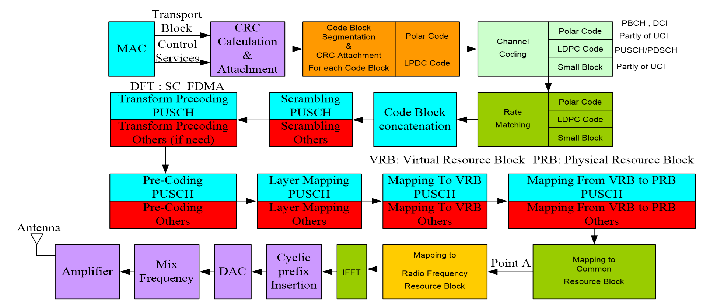

OFDM baseband signal generation for all channels except PRACH , please refer to Attachment B.

[Aspect 2] Basic knowledge summary and draft version for the Algorithm process of De Rate Matching Module of PUSCH(LDPC) ,
the whole Module including two Steps：
[Step 1] Deinterleaving
[Step 2] Reverse process for Bits Selection

Based on the following research work before :
[1] Analyze and familiarize with the process of LDPC channel coding, focusing on the data frame structure of the output sequence (Figure A)
[2] Analyze and master the process of LDPC data Rate Matching (Figure B), and perform Reverse Analysis

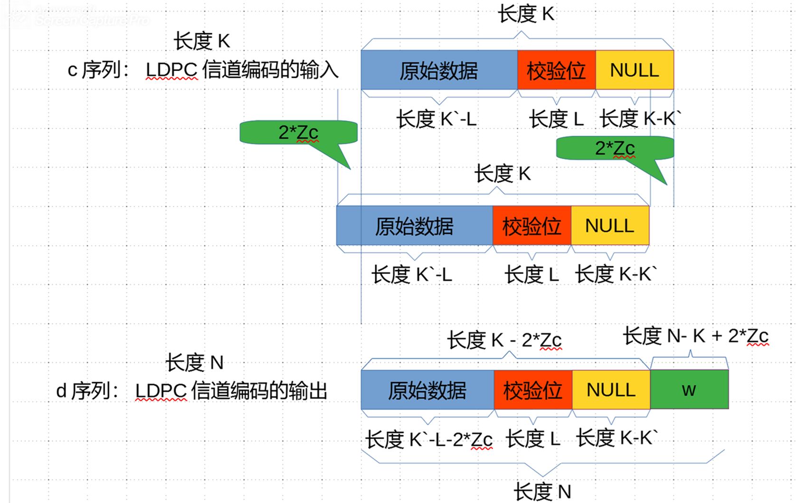

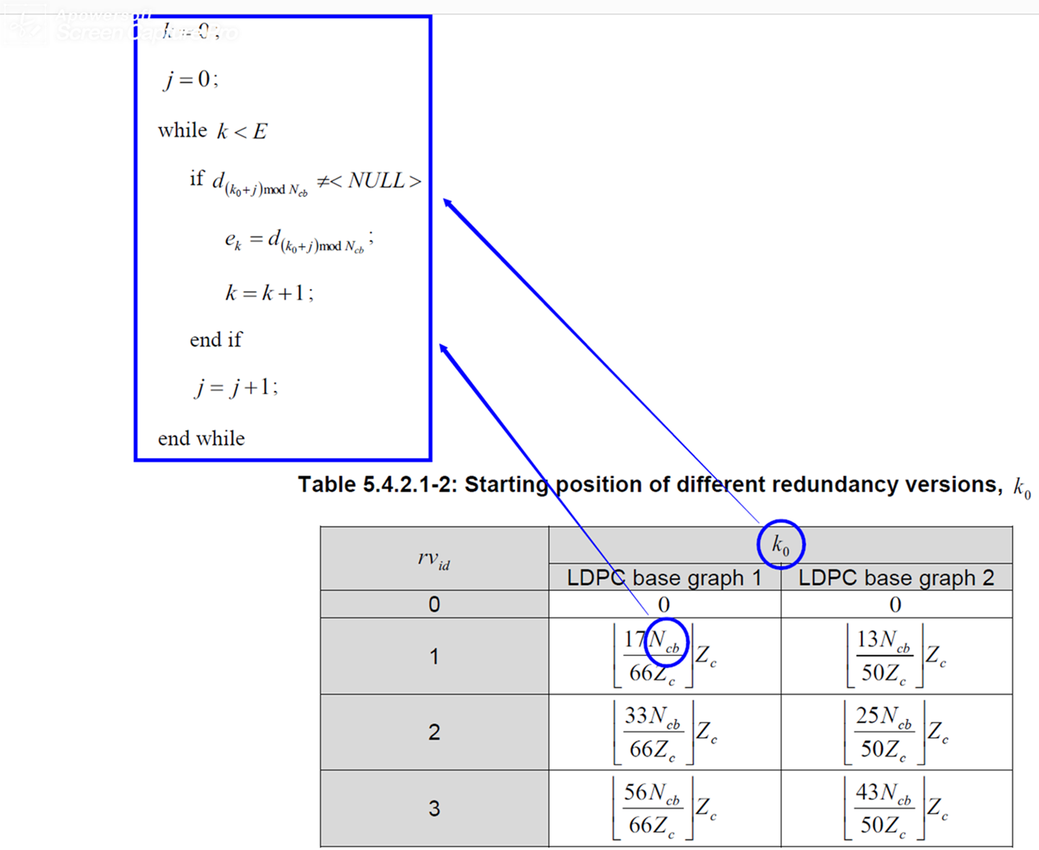

This the initial version and need review and guidelines~
PUSCH DeRateMatching Algorithm Design Draft Version , please refer to Attachment C.

[Aspect 3]

- Meeting morning of Hongkong , have Received challenge ,
we will have the implementation of PDSCH process internal of FPGA for Mapping from Virtual Resource Block to Physical Resource Block
The important key point is that : ARM Processor should send the Mapping relationship by Memory Index scheme , real time and accuracy.

Virtual Resource Block : Subcarrier Number internal of Resource Block Number -----→ Physical Resource Block : Subcarrier Number internal of Resource Block Number

PUSCH Mapping from Virtual Resource Block to Physical Resource Block, please refer to Attachment D.

- Meeting afternoon of Hongkong , have understanding and master the implementation for De Rate Matching and De Scrambling module~

[Next week work Plan] :

[1] FPGA High Level Design Document and initial version RTL Design (Verilog HDL)

- Achievement the HLD of De Rate Matching Module for PUSCH LDPC Channel Coding ;
- Achievement the initial version RTL Design (Verilog HDL) of De Rate Matching Module for PUSCH LDPC Channel Coding ~

If possible , can help others such as descrambling module

[2] 5G NR standard and protocol study , research , understanding achieve to master

Focus on [3GPP TS 38.211 V15.5.0 (2019-03)] ,
Basic knowledge and to support implementation of PDSCH process internal of FPGA for Mapping from Virtual Resource Block to Physical Resource Block

7.3.1 Physical downlink shared channel ............................................................................................................. 76
7.3.1.1 Scrambling ............................................................................................................................................ 76
7.3.1.2 Modulation ........................................................................................................................................... 76
7.3.1.3 Layer mapping ...................................................................................................................................... 76
7.3.1.4 Antenna port mapping .......................................................................................................................... 77
7.3.1.5 Mapping to virtual resource blocks ...................................................................................................... 78
7.3.1.6 Mapping from virtual to physical resource blocks ............................................................................... 78
Warm regards
Libo Sun
Casa Technologies Limited
Room B4-04, 4/Floor, CaiFu Building(彩福大厦), Gangxia Subway station(岗厦地铁站), B Port, Shenzhen.
(E) libo.sun@casa-systems.com
(M) 86 15889672958
http://www.casa-systems.com
___________________________________
CONFIDENTIAL NOTE: The message and any attachments in this email are confidential and intended solely for the addressee(s). Information contained herein may be privileged, confidential and exempt from disclosure under applicable law. If you received this message in error please delete it and notify us immediately. If this message was misdirected, Casa Technologies Limited does not waive any confidentiality or privilege. Any unauthorised use, copying or dissemination of this email or any attachments to it is strictly prohibited. Please note that e-mails are susceptible to alteration and message transmission is not guaranteed to be secure.
PLEASE CONSIDER OUR ENVIRONMENT BEFORE PRINTING THIS E-MAIL. THANK YOU!

